**PRACTICAL-4.2**

**AIM:** DEFAULT ROUTIING

**THEORY:**

This is the method where the router is configured to send all packets towards a single router (next hop). It doesn't matter to which network the packet belongs, it is forwarded out to the router which is configured for default routing. It is generally used with stub routers.

 The default route is a configuration of the Internet Protocol (IP) that establishes a forwarding rule for packets when no specific address of a next-hop host is available from the routing table or other routing mechanisms.

Normally, if a specific route to a particular network does not exist, a router will drop all traffic destined to that network. A default route, or gateway of last resort, allows traffic to be forwarded, even without a specific route to a particular network. The default route is identified by all zeros in both the network and subnet mask (0.0.0.0 0.0.0.0). It is the least specific route possible, and thus will only be used if a more specific route does not exist (hence “gateway of last resort”).

**TOPOLOGY:**

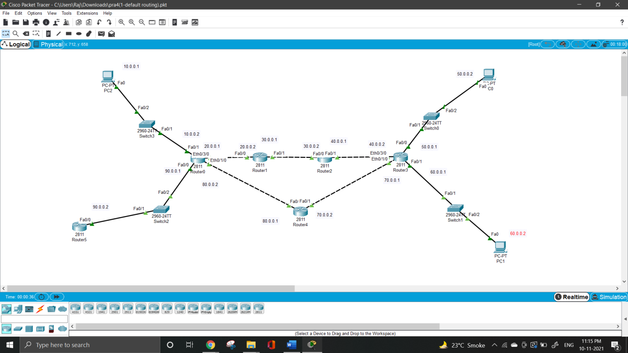

**COMMAND:**

Route0:

* In this first we have to arrange router , pc and switches .
* Than connect all together.
* After connection give pc to their ip address.
* Than after take first router and give it to ip addresses and and set it.
* After set ip addresses for static and default routing we have to use command ip route 0.0.0.0 0.0.0.0 20.0.0.2.
* Like this we have to use command for all other routers.

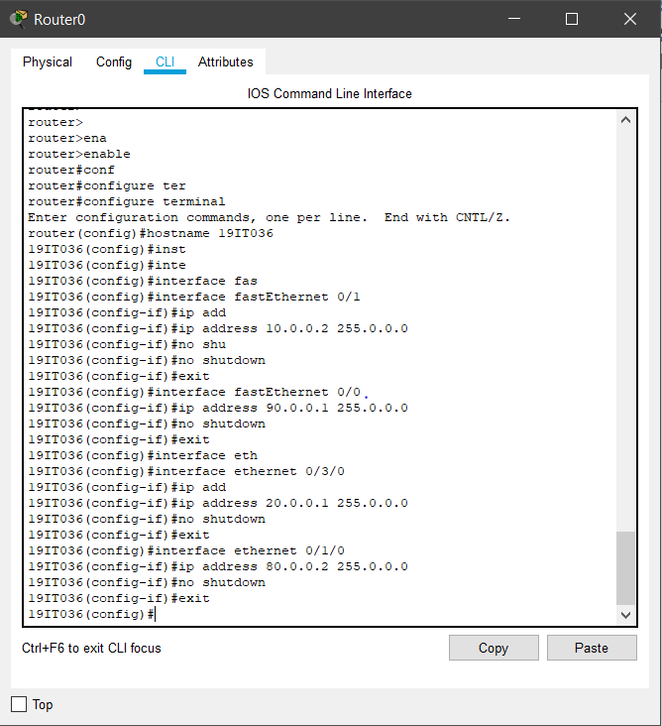

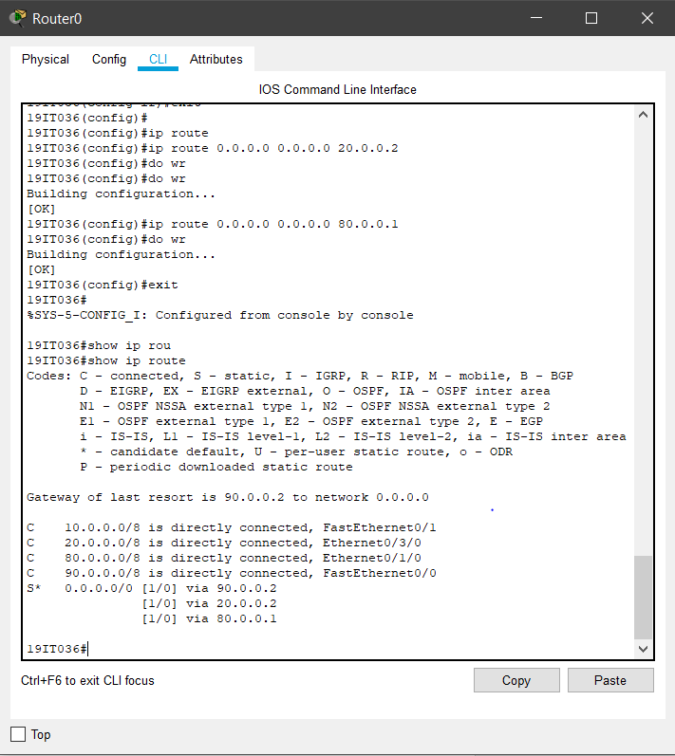

Route1:

* In router 1 first set ip address and than use command for routing.

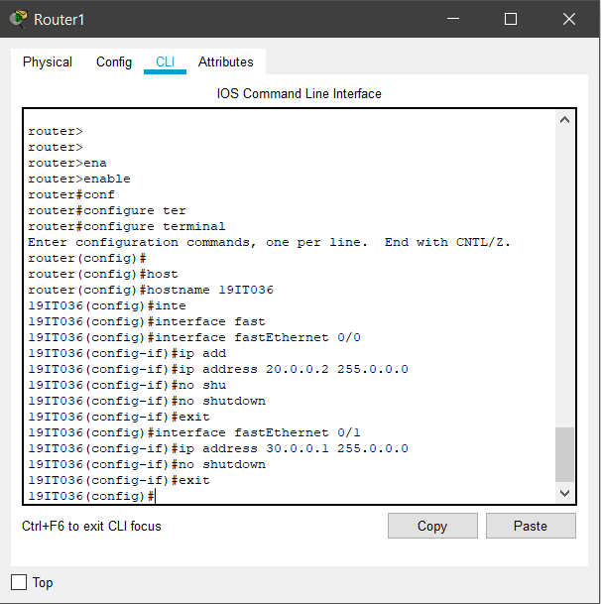

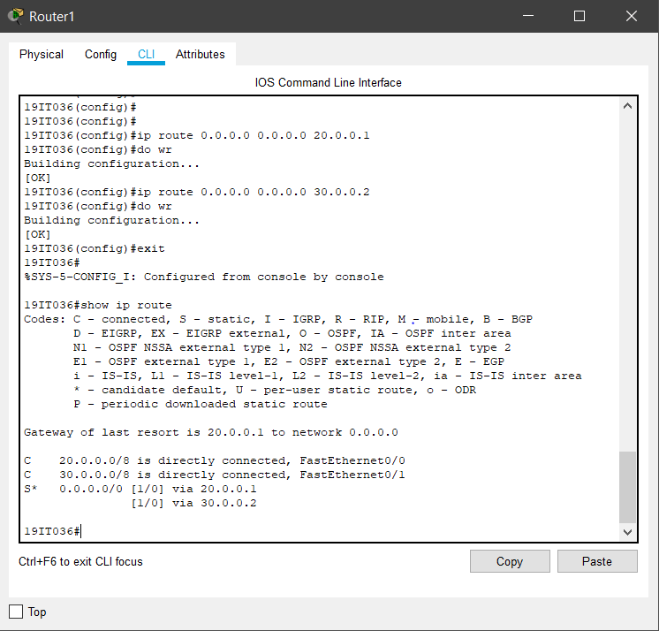

Route2:

* In router 2 first set ip address and than use command for routing.

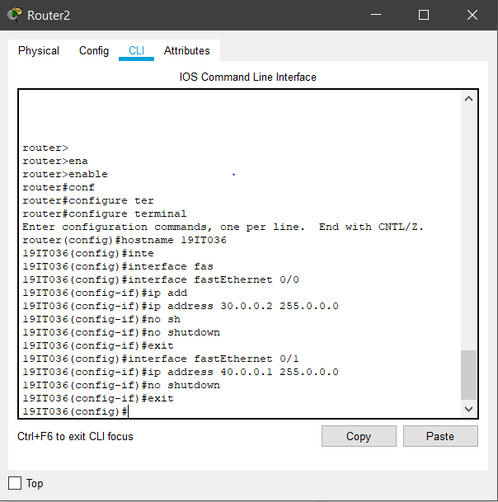

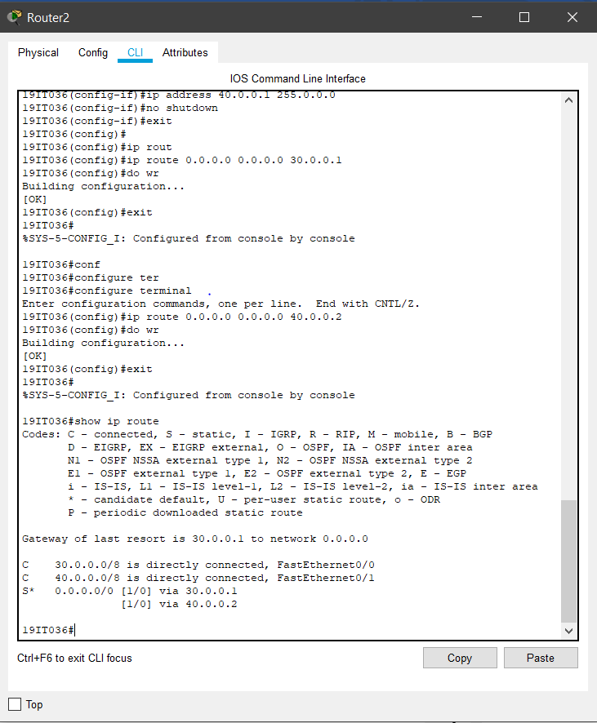

Route3:

* In router 3 first set ip address and than use command for routing.

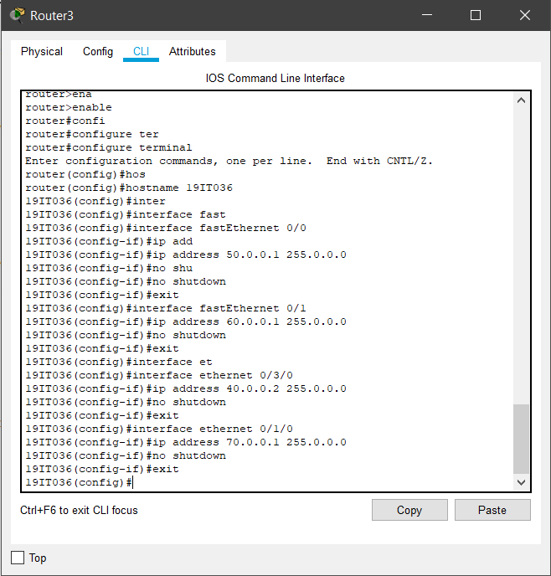

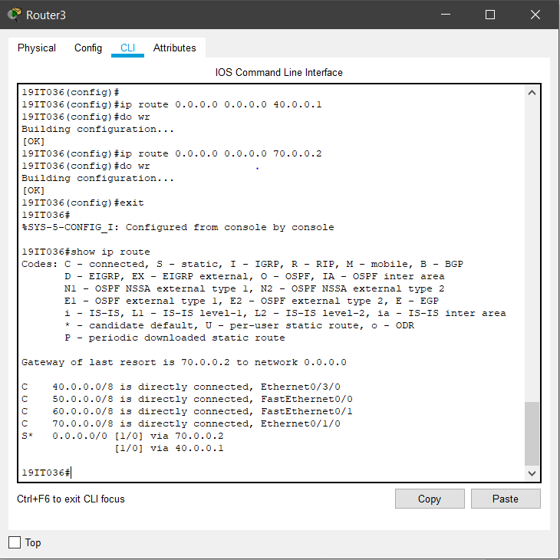

Route4:

* In router 4 first set ip address and than use command for routing.

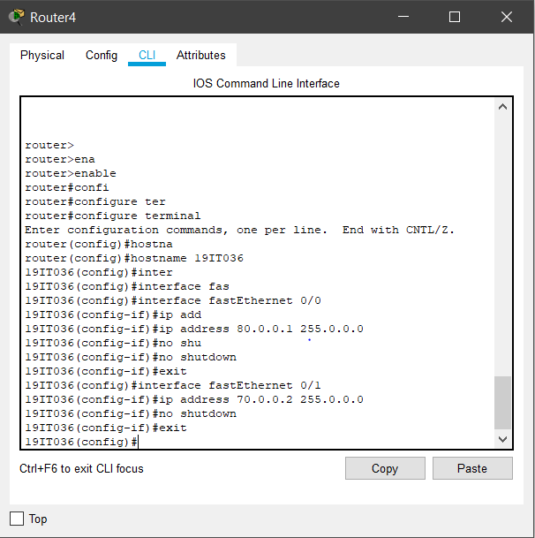

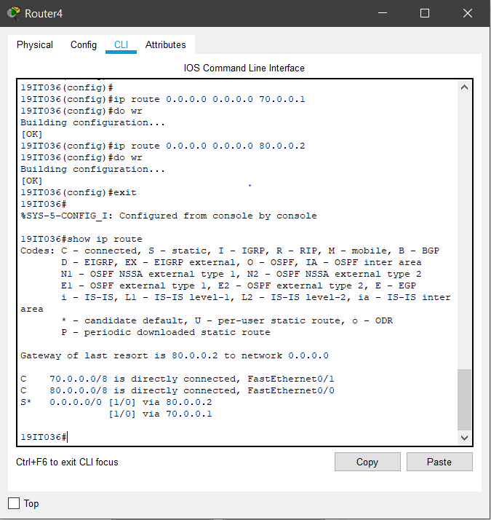

Route5:

* In router 5 first set ip address and than use command for routing.

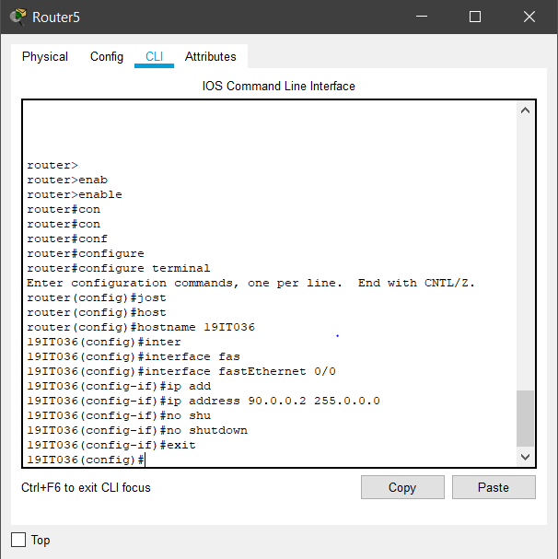

**OUTPUT:**

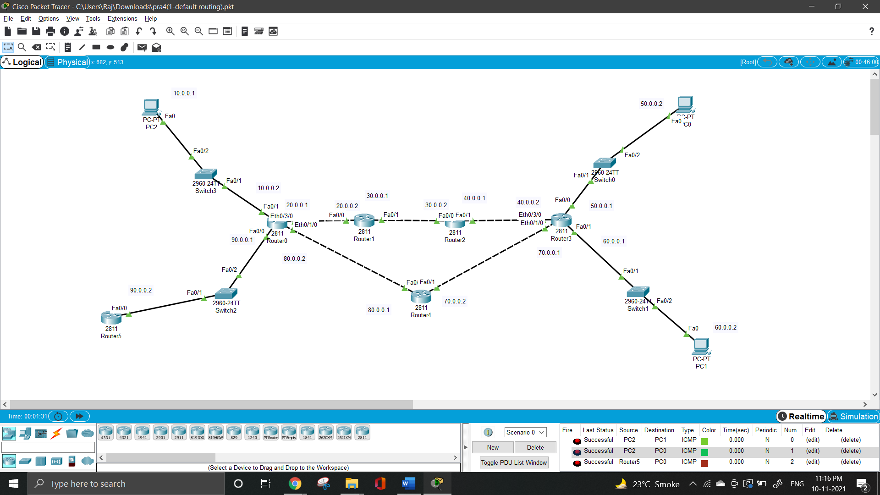

**LEARNING OUTCOME**: By performing this practical I understand what is what is default routing. In this practical we are doing routing using simple defaultrouting.